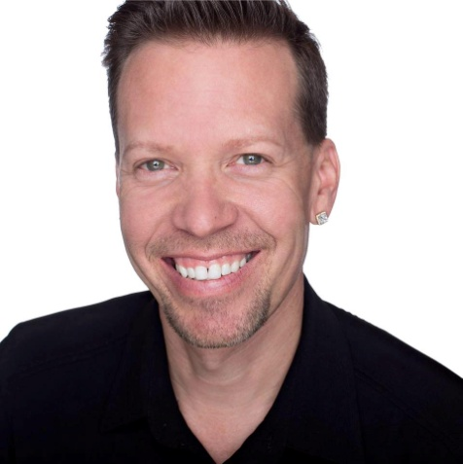 **Eugene Ebner – TV/Radio Show Host Personality and Producer**

* Producer, Co -Host of IAD Radio - 2007-2009
* Producer, Host of Diversity Now Radio - 2010-2012
* Producer, Host of Conversations with Eugene Ebner internet TV Talk Show- 2014-2017
* Live host/interviewer GALA Choruses National Festival -2016
* Guest on the Everyday Show – FOX31-Denver and Colorado & Company – 9News- Denver
* Personality and host on Denver Channel ABC 7
* Radio Show listening base – 35,000
* Internet TV Talk Show / Entertainer total views – 30,000
* Social media profiles and fan pages – 9,000

**Eugeneebner.com – Demo Reel**

**Ebner-pageproductions.com**

**Eugene Ebner** has performed and produced exciting media projects and special events for audiences across the world since the 1990’s.  Eugene's bachelor's degree in vocal performance from the University of Arizona, his musical training in Salzburg, Austria and his devotion to humanitarian efforts has made him a driving force in the entertainment scene.  Eugene thrives on mastering a wide spectrum of vocal styles, ranging from Broadway (Guys and Dolls, Camelot, Fiddler on the Roof, Paint Your Wagon) and operetta to dramatic ballads, while adding his own special touch and flare.  Eugene's mission in life is to be an extraordinary role model for all people by uniting one community at a time through acceptance and love. Eugene has danced on stage with entertainment legend Diana Ross numerous times, has performed in front of the Capitol Building in Washington, DC as 'Wonder Woman' and has sung the national anthem three times at Colorado Rockies games for over 25,000 people.  As host and co-producer of Diversity Now Radio, a show that encouraged others to embrace diversity and change the world, Eugene interviewed such superstars as Olivia Newton-John and Vanessa Williams.  Eugene led motor coach tours for four years throughout the National Parks of the West and local city tours of Denver. Currently Eugene is the executive producer and host of Conversations with Eugene Ebner, an internet-based TV show that features interviews with diverse individuals and showcases their stories and experiences to inspire, entertain and educate others.  In addition, Eugene and his husband Paul Page created Ebner - Page Productions which specializes in media projects including internet television, cabaret shows for charity and special events.